**Project Report**

**On**

**Online**

**Job Portal**

|  |  |
| --- | --- |
| **Submitted By:** | **Guided By:** |
| **1. Debjit Basu** | **Dr. Deepsubhra Guha Roy** |
| **2. Mrittika Basu** | **Professor of Institute of** |
| **Team No- 15** | **Engineering and Management** |

**Institute Of Engineering & Management**

**CERTIFICATE**

This is to certify that Software Engineering project report entitled **‘Job Portal’** is the work carried out **Debjit Basu and Mrittika Basu,** students of B.Tech Computer Science & Business V Semester, Institute of Engineering & Management under the supervision of **Dr. Deepsubhra Guha**

**Roy**, **Assistant Professor**, **Department of Computer Science & Business**

**System, Institute of Engineering & Management**

This report has not been submitted to any other organization/institution for the award any other degree/diploma.

**Dr. Deepsubhra Guha Roy (Project Guide)**

# ACKNOWLEDGEMENT

The satisfaction that accompanies that the successful completion of any task would be incomplete without the mention of people whose ceaseless cooperation made it possible, whose constant guidance and encouragement crown all efforts with success.

We are grateful to our project guide Dr. Deepsubhra Guha Roy for the guidance, inspiration and constructive suggestions that helpful us in the preparation of this project.

We also thank our colleagues who have helped in successful completion of the project.

# CONTENTS

1. **Introduction**
   1. Purpose
   2. Scope
   3. Technologies used
   4. Overview
2. **Overall Description** 
   1. Goals of Proposed System
   2. Background
   3. Project Requirements
   4. User Characteristics
   5. Constraints
   6. Definition of Problems
   7. Alternative Solutions
3. **Feasibility Study** 
   1. Technical Feasibility
   2. Economical Feasibility
   3. Operational Feasibility
   4. Schedule Feasibility
4. **Data Flow Diagrams**
5. **Entity Relationship Diagram**
6. **Data Tables**
7. **Snapshots**
8. **Conclusion**
9. **Github link**

## INTRODUCTION

### 1.1 Purpose

An online job portal serves as a digital platform that connects job seekers and employers. Its primary purpose is to facilitate the job search and recruitment process by providing a centralized, efficient, and accessible space for both job seekers and employers to interact. Here's an elucidation of the purposes and benefits of an online job portal:

1. Matching Job Seekers with Opportunities:
   * Job seekers can create profiles and search for job openings that match their skills, qualifications, and career aspirations.
   * They can filter job listings based on various criteria such as location, industry, experience level, and job type, making it easier to find relevant opportunities.
2. Efficient Recruitment for Employers:

* Employers can post job openings and access a pool of potential candidates. This process saves time and resources compared to traditional methods like newspaper advertisements.
* Employers can search for suitable candidates based on their qualifications, experience, and other criteria. 3. Accessibility and Convenience:
* Online job portals are accessible 24/7 from anywhere with an internet connection, providing convenience for both job seekers and employers. This accessibility makes job searching and hiring more efficient and inclusive.

4. Wider Reach:

- Job portals have a vast reach, allowing employers to reach a larger audience of potential candidates. This is especially useful when hiring for positions with specific skill requirements or for companies with a national or global presence.

1. Time and Cost Savings:
   * Traditional job advertisements and recruitment processes can be timeconsuming and costly. Online job portals significantly reduce these expenses, making it a cost-effective solution for both job seekers and employers.

1. Customization and Personalization:
   * Job seekers can tailor their profiles, resumes, and job preferences to match their career goals. Employers can customize job postings to attract the most suitable candidates. 7. Notifications and Alerts:
   * Job seekers can set up notifications and alerts to receive updates on new job postings that match their criteria. This feature helps them stay up to date with relevant opportunities.
   * Employers can also receive alerts when candidates meeting their requirements create profiles or apply for positions.

8.Data and Analytics:

* + Job portals often provide data and analytics tools for employers to track the effectiveness of their job postings and recruitment efforts. This information can be used to refine hiring strategies. 9.Simplified Application Process:
  + Online job portals typically offer a streamlined application process, allowing job seekers to apply for multiple positions with minimal effort, as their profile information can be used across multiple applications.

10. Feedback and Ratings:

* Many job portals have features for job seekers to rate and review employers, and vice versa. This transparency helps both parties make informed decisions about potential matches. 11. Industry Insights and News:
* Job portals may include sections that provide industry-specific news, trends, and insights, helping job seekers and employers stay informed about the job market and the latest developments in their field.

### 1.2 Scope

The scope of the project, which involves the development of an online job portal website, is extensive and includes various aspects that need to be considered. Here's an overview of the scope of the project:

1. Frontend Development:
   * Creating a user-friendly and responsive user interface for the website using HTML, CSS, and JavaScript.
   * Designing and structuring web pages for the Home, About Us, Employer, Job Seeker, Latest News, and Contact Us sections.
   * Implementing user authentication and registration forms for job seekers and employers.
2. Backend Development:

* Developing the server-side functionality using PHP.
* Designing and managing the MySQL database to store user information, job listings, and other relevant data.
* Implementing user registration, login, and password recovery processes.
* Building logic for job posting, job searching, and application submission.

3. User Roles and Permissions:

* Defining roles for job seekers and employers, each with different access and functionality.
* Ensuring appropriate permissions and restrictions for each user type.

1. Job Search and Matching:
   * Creating a job search and filtering system, allowing job seekers to find relevant job listings.
   * Implementing algorithms to match job seekers with suitable job openings based on their profiles and preferences.
2. Employer Features:
   * Enabling employers to post job openings, manage job listings, and view job seeker profiles.
   * Building a dashboard for employers to track and manage the recruitment process.
3. Job Seeker Features:
   * Allowing job seekers to create and manage profiles, including uploading resumes and personal information.
   * Facilitating the job application process, allowing job seekers to apply for positions and track their application status.
4. Latest News Section:

* Setting up a news section to display industry-related news and updates.
* Implementing features for adding, editing, and categorizing news articles.

8. Contact Us:

* Providing contact details for users to reach out with inquiries, feedback, or support.
* Creating a mechanism for users to submit contact forms or send messages.

9. Security and Privacy:

* Implementing security measures to protect user data and the website from potential threats.
* Ensuring data privacy and compliance with relevant regulations (e.g., GDPR).

1. User Experience (UX):
   * Focusing on creating an intuitive and user-friendly experience for both job seekers and employers.
   * Optimizing website performance and responsiveness.
2. Testing and Quality Assurance:
   * Conducting thorough testing to identify and resolve bugs, issues, and usability concerns.
   * Ensuring the website functions as expected and provides a seamless experience. 12. Documentation:
   * Creating user guides and documentation for website users, administrators, and developers.
   * Documenting the project's codebase, structure, and functionalities for future maintenance and updates
3. Deployment and Hosting:
   * Deploying the website on a hosting server and ensuring it's accessible to users.
   * Managing hosting services, domain registration, and server maintenance.
4. Marketing and Promotion:
   * Planning strategies to promote the website and attract job seekers and employers to the platform.
   * Consideration of marketing channels, such as social media, SEO, and email campaigns.
5. Feedback and Improvement:
   * Incorporating feedback mechanisms for users to provide suggestions and report issues.
   * Planning for continuous improvement and updates to meet evolving user needs and technological advancements. 16. Compliance and Legal Considerations:
   * Ensuring the website complies with legal regulations and requirements related to user data and privacy, equal opportunity employment, and other relevant laws.

### 1.3 Technologies Used

The development of an online job portal website involves various technologies and components to create a robust and user-friendly platform. Here's a brief overview of the key technologies and their roles in the project:

**HTML (Hypertext Markup Language):**

* HTML is the standard markup language used to create the structure and content of web pages.
* It defines the layout and elements of the website, including headings, paragraphs, links, forms, and more.

**CSS (Cascading Style Sheets):**

* CSS is used to control the presentation and design of web pages.
* It allows for the customization of fonts, colors, layouts, and other visual aspects, ensuring a visually appealing and consistent design.

**JavaScript:**

* JavaScript is a scripting language that provides interactivity and dynamic features to web pages.
* It enables functions like form validation, user interactions, and dynamic content updates without the need to reload the entire page. **PHP (Hypertext Preprocessor):**
* PHP is a server-side scripting language used to create the backend of the website.
* It handles user authentication, processes form submissions, interacts with the database, and generates dynamic content.

**MySQL:**

* MySQL is a relational database management system used to store and manage data for the website.
* It is employed to store user information, job listings, news articles, and other relevant data.

### 1.4 Overview

The Online Job Portal project is a web-based platform designed to connect job seekers with employers by offering user-friendly features such as user registration and authentication, job search and posting, comprehensive user profiles, an informative news section, and contact support. It employs technologies like HTML, CSS, JavaScript, PHP, and MySQL to create a seamless user experience, with a strong focus on data security and responsive design. The platform aims to streamline the job search and recruitment processes, making it accessible, efficient, and privacy-compliant, while also considering strategies for marketing and user feedback to enhance its utility.

### 2. Overall Description

#### 2.1 Goals of Proposed System

The goals of the proposed Online Job Portal system are to:

* **Efficient Job Matching:** Facilitate the efficient matching of job seekers with suitable job openings, providing a streamlined and user-friendly interface for job searching and application.
* **Effective Recruitment:** Enable employers to find and connect with qualified candidates by offering a platform for posting job listings, managing applications, and accessing comprehensive job seeker profiles.
* **User Convenience:** Provide a convenient, 24/7 accessible platform for users to create, manage, and access their profiles, making the job search and recruitment processes hassle-free.
* **Data Security and Privacy:** Implement robust security measures to safeguard user data and privacy, ensuring compliance with relevant regulations and building trust among users.
* **Responsive Design:** Ensure that the platform is accessible and functional on various devices and screen sizes, enhancing user experience and inclusivity.
* **Industry Information:** Keep users informed with an up-to-date news section, providing relevant industry insights and trends to assist in informed decision-making.
* **User Support:** Offer a contact support system for users to seek assistance and address inquiries, enhancing their overall experience.
* **Continuous Improvement:** Consider marketing strategies and feedback mechanisms to attract a wide user base and gather valuable input for ongoing enhancements, ensuring the system remains responsive to evolving needs and trends in the job market.

#### 2.2 Background

The Online Job Portal project was conceived to address the growing demand for a digital platform that simplifies and modernizes the job search and recruitment processes. In an era of online connectivity, the project seeks to leverage cutting-edge web technologies to create a user-centric space where job seekers can effortlessly discover job opportunities, manage their profiles, and apply for positions, while employers can efficiently post job listings, evaluate candidate profiles, and streamline recruitment. With a focus on data security, user experience, and responsiveness, the proposed system aims to bridge the gap between job seekers and employers, contributing to a more dynamic and responsive job market.

#### 2.3 Project Requirements

Project requirements for the Online Job Portal system include secure user registration, user profiles, job listings management, job search, user interaction, a news section, contact support, responsive design, data security, and feedback and marketing strategies.

#### 2.4 User Characteristics

The user characteristics for the Online Job Portal system encompass two primary categories:

* **Job Seekers:**
* Job seekers are individuals actively searching for employment opportunities.
* They may vary in experience, qualifications, and fields of interest.
* Characteristics include creating and managing profiles, applying for jobs, and receiving job alerts.
* **Employers:**
* Employers are organizations or individuals seeking to recruit and hire employees.
* They can range from small businesses to large corporations.
* Characteristics include posting job openings, reviewing job seeker profiles, and managing the recruitment process.

The system is designed to cater to the distinct needs and goals of both job seekers and employers, offering features and functionalities that align with their respective characteristics and objectives.

#### 2.5 Constraints

Constraints of the Online Job Portal system include budget and time limitations, technology constraints, regulatory compliance, scalability concerns, security requirements, user adoption, user feedback integration, infrastructure reliability, resource availability, and competition in the job portal market. These factors influence the project's development and long-term success.

#### 2.6 Definition of Problems

In the context of the Online Job Portal project, problems refer to challenges or issues that may arise during the project's development, deployment, or operation. These problems could include technical issues, such as software bugs or system performance issues, as well as operational challenges like user adoption or data security concerns. Addressing these problems is essential to ensure the project's successful implementation and ongoing functionality.

#### 2.7 Alternative Solutions

* **Technical Support and Debugging:** Employ experienced developers and IT professionals to promptly identify and rectify technical issues, ensuring the website's smooth operation.
* **User Training and Education:** Provide user guides and training materials to help users, both job seekers and employers, navigate and make the most of the platform effectively.
* **Security Audits and Compliance Checks:** Conduct regular security audits and ensure compliance with data protection regulations to protect user data and build trust.
* **Performance Optimization:** Invest in performance optimization to enhance the platform's speed and responsiveness, reducing load times and ensuring a seamless user experience.
* **Marketing and Outreach:** Implement targeted marketing strategies to attract more job seekers and employers, expanding the user base and improving the platform's reach and effectiveness.
* **Feedback Integration:** Actively seek and incorporate user feedback into ongoing development, continuously improving the platform based on user suggestions and needs.
* **Resource Scaling:** Assess resource availability and consider scaling infrastructure, as needed, to accommodate increasing user traffic and data volume.
* **Competitive Strategy:** Develop a unique selling proposition or differentiate the platform from competitors to stand out in the crowded job portal market.

#### 3. *Feasibility Study*

Before embarking on the development of online Job Portal DBMS project, it is crucial to conduct a comprehensive feasibility study to assess the project's technical, economical, operational, and schedule feasibility.

##### 3.1 Technical Feasibility

Technical feasibility for the Online Job Portal project is high, given the availability of mature and well-established technologies for web development.

HTML, CSS, JavaScript, PHP, and MySQL are widely used and supported.

Additionally, the project's technical requirements, such as user registration, job posting, and database management, can be effectively implemented using these technologies. While challenges may arise, such as addressing potential scalability issues and ensuring data security, these are manageable with appropriate expertise and resources.

##### 3.2 Economical Feasibility

Economically, the project appears feasible due to the potential for generating revenue through job listing fees, premium services for employers, and advertising opportunities. The project's costs, including development, maintenance, and marketing, must be carefully managed to ensure profitability. A detailed cost-benefit analysis is essential to assess the project's financial viability.

##### 3.3 Operational Feasibility

Operationally, the project's feasibility is promising, as it addresses a real need in the job market. It aims to streamline job search and recruitment processes, benefiting both job seekers and employers. By offering user-friendly features and valuable services, the platform is likely to attract and retain users. Effective operational management, including support services, is essential to maintain a high level of user satisfaction.

##### 3.4 Schedule Feasibility

The schedule feasibility of the project depends on the allocated time frame and resource availability. The project can be completed within a reasonable time, assuming skilled personnel and adequate resources are in place. A well-defined project schedule with milestones and deadlines will help ensure timely delivery. However, any unforeseen delays or changes in project scope must be carefully managed to stay on track.

### 

### Dataflow Diagram

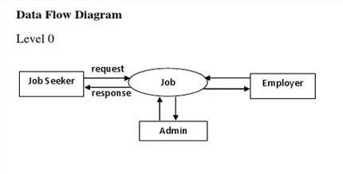

*DFD LEVEL 0*

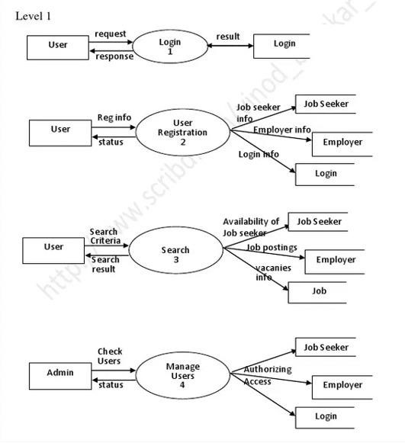

#### *DFD LEVEL – 1*

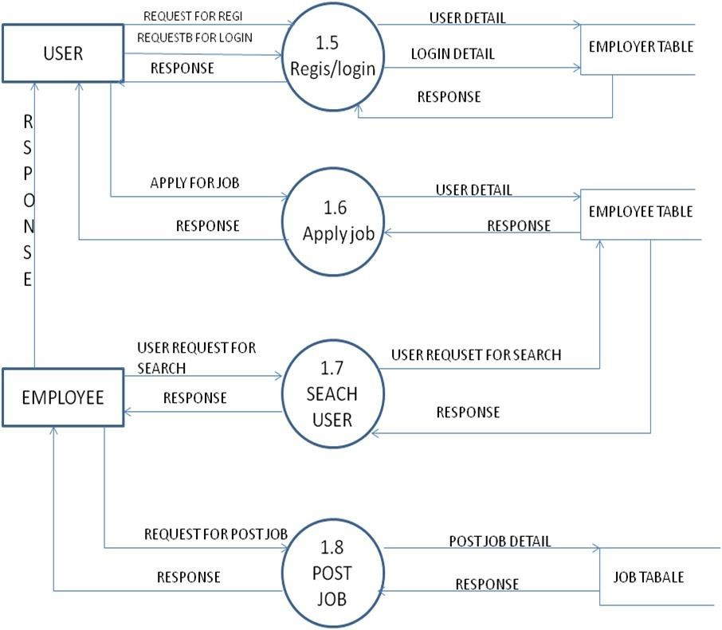

***DFD LEVEL 2***

### 

### 5. ENTITY RELATIONSHIP MODEL

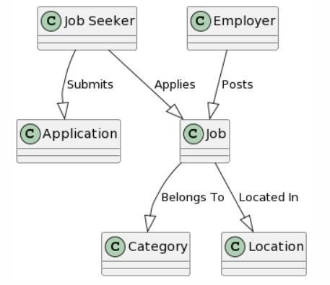

***[GETTING INTO THE PROJECT:](https://github.com/kishan0725/Hospital-Management-System" \l "getting-into-the-project)***

HOME PAGE

The home page of a job portal website is the main landing page where users access job listings, company information, and search tools. It provides a welcoming and user-friendly interface, making it easy for visitors to browse and search for job opportunities.

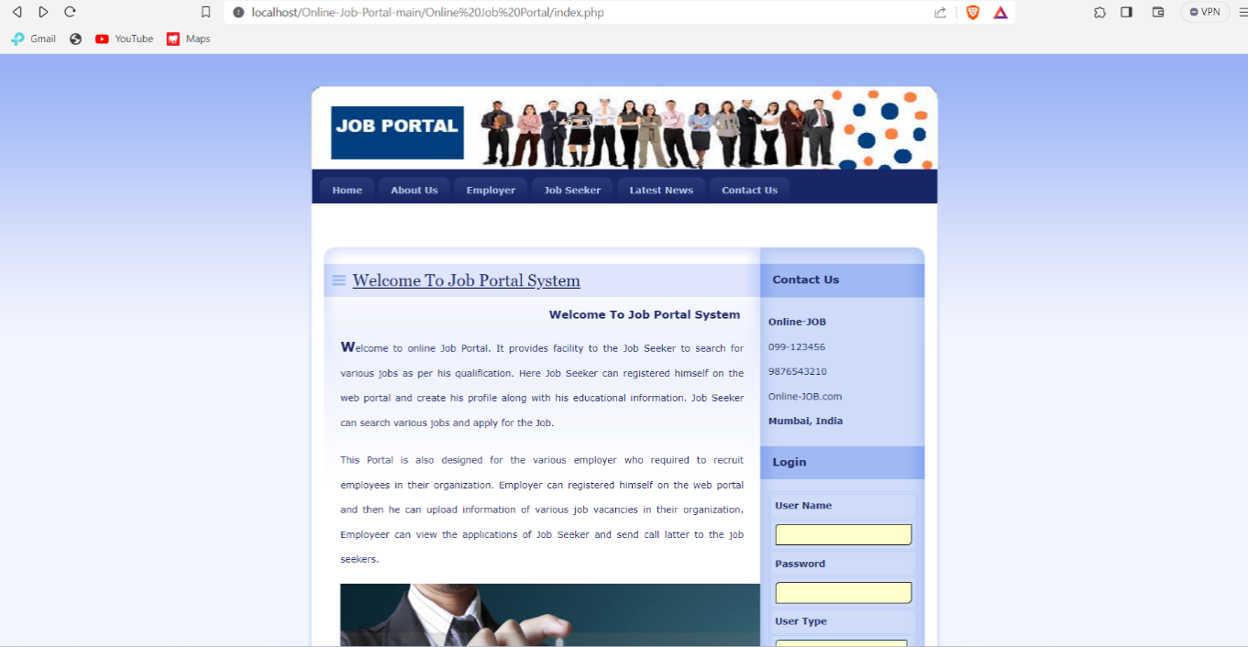

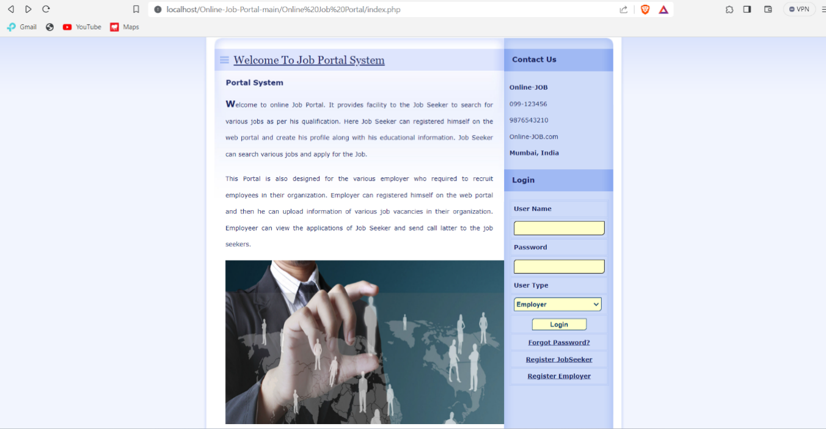

About Us

The "About Us" section of a job portal website typically provides information about the website's mission, history, and values. It may also detail the team behind the platform and its commitment to connecting job seekers with employers, ultimately fostering career growth and opportunities.

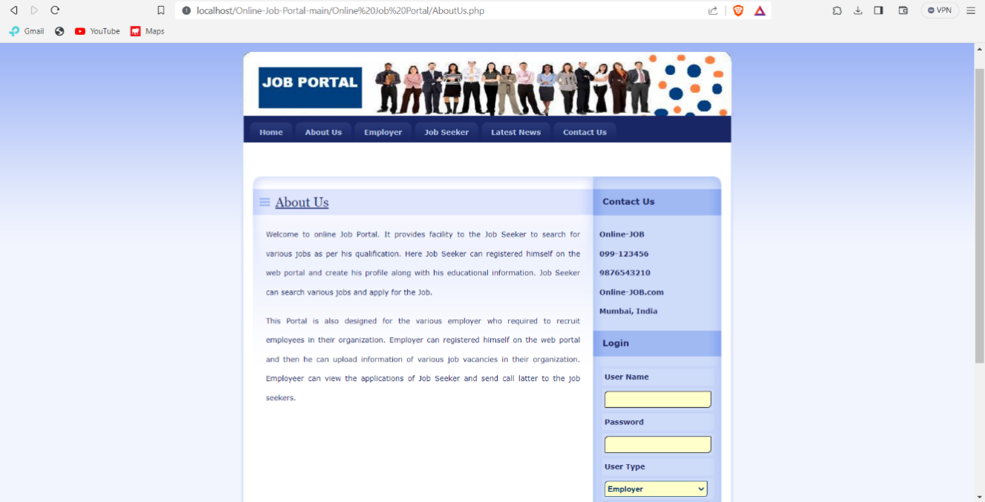

OUR EMPLOYEES

It seems like you're looking for information or content related to "our employees" on a job portal website. However, your request is a bit unclear. If you have a specific question or need more information, please provide additional details so I can assist you more effectively.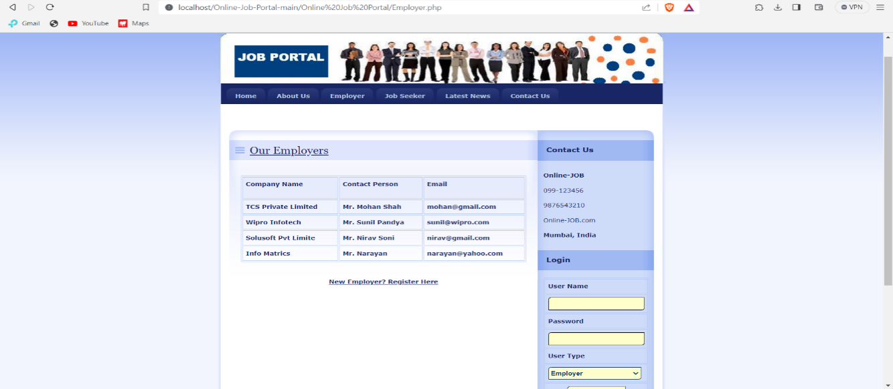

JOB SEEKER

The job seeker section of a job portal website is where individuals looking for employment can create profiles, upload resumes, and search for job listings. It typically includes features like personalized job alerts, application tracking, and resources to help job seekers with their career search, such as resume building tips and interview advice.

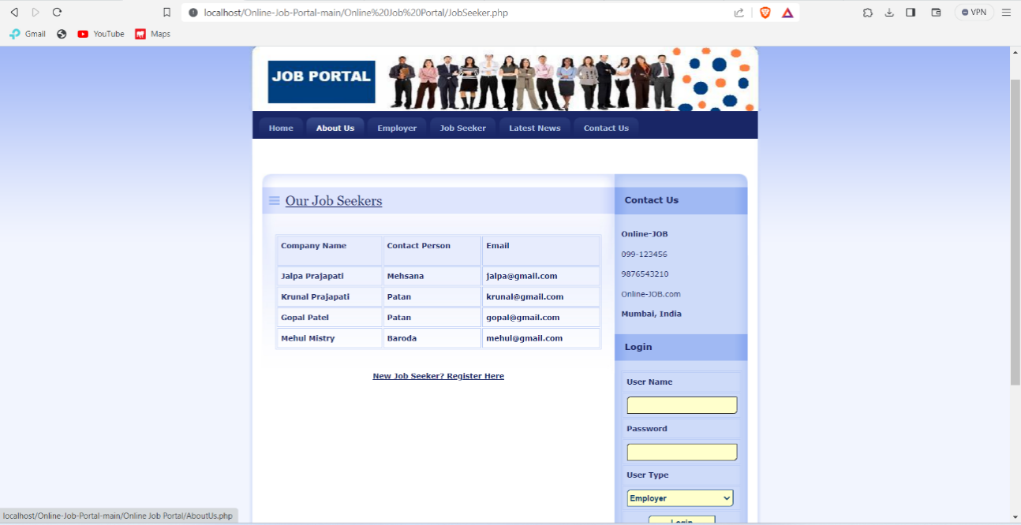 LATEST NEWS

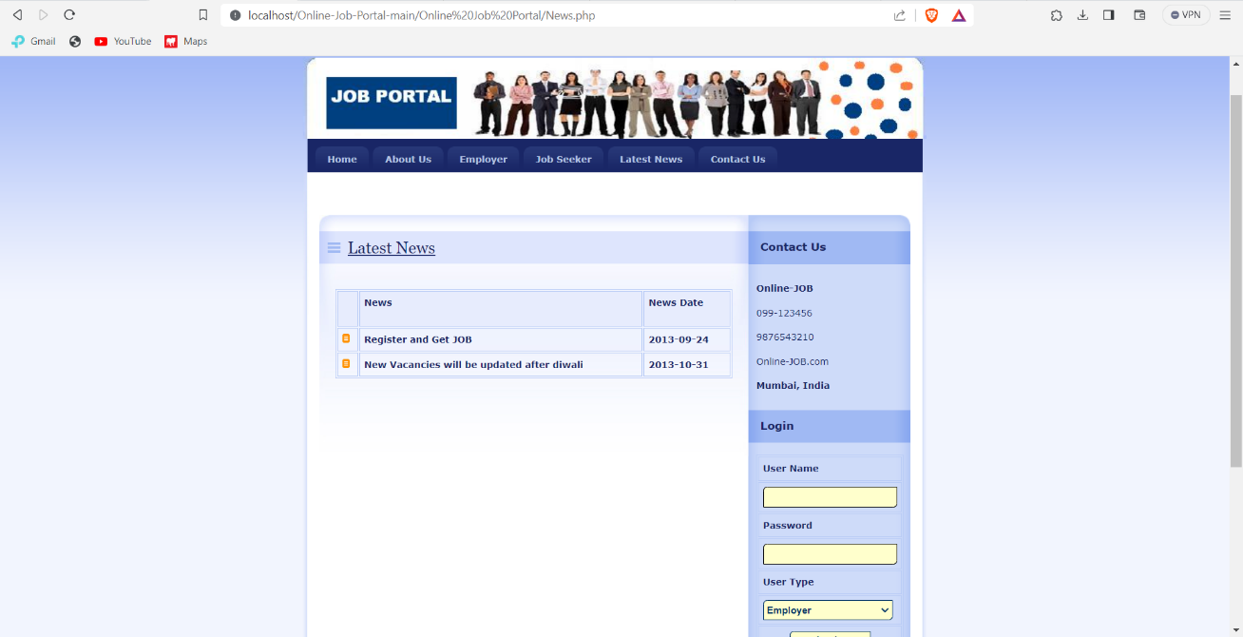A "Latest News" section on a job portal website typically provides updates and articles related to the job market, career advice, industry trends, and job search tips. It helps job seekers and employers stay informed about relevant news and developments in the employment field.

JOB SEEKER REGISTRAION FORM

Employee registration on a job portal website involves creating an account or profile for job seekers. This typically includes providing personal information, work experience, education, skills, and preferences. After registration, job seekers can search for job listings, apply to positions, and manage their job search through the portal.

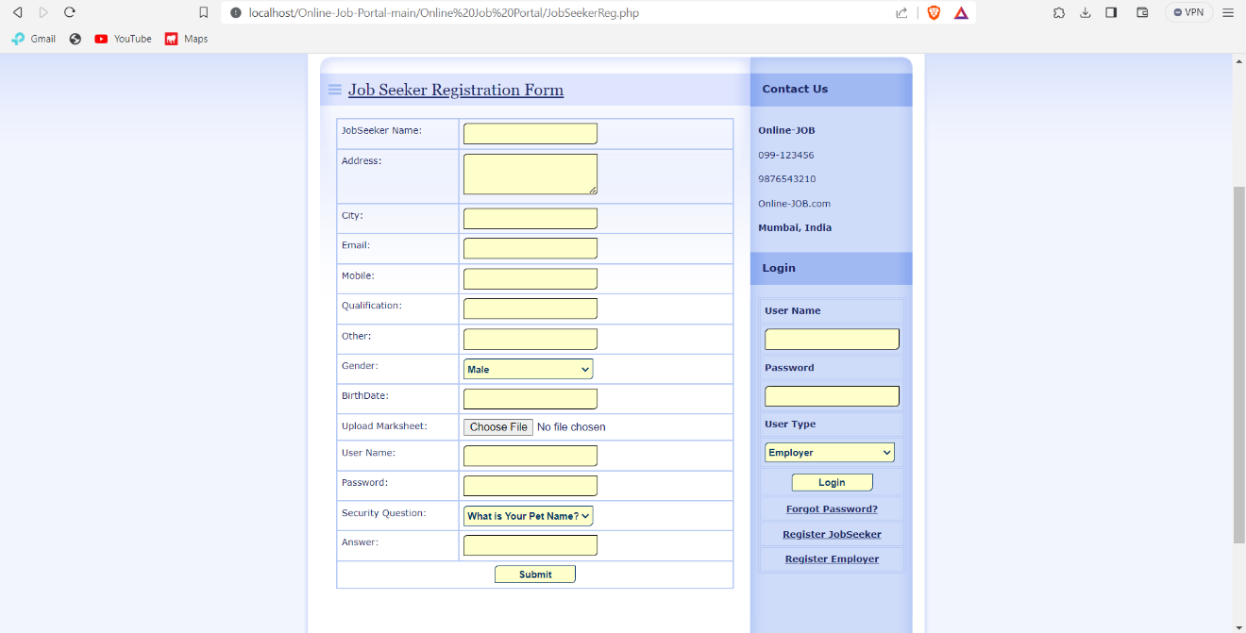

EMPLOYEE REGISTRATION FORM

Job registration on a job portal website involves employers or companies creating accounts to post job listings. This typically includes providing information about the job, such as job title, description, requirements, location, and application instructions. Employers can also use these accounts to manage and track applications from potential candidates.

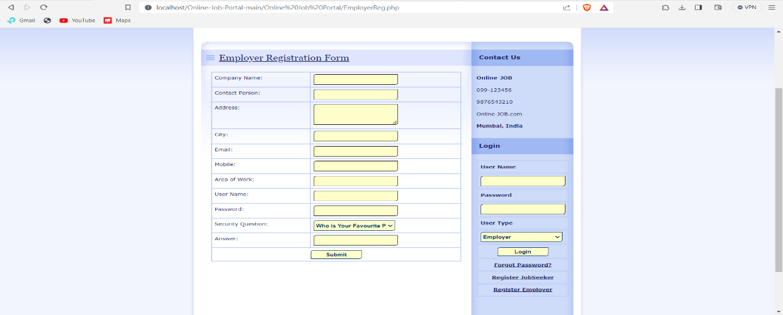

8.Conclusion

The Online Job Portal project represents a substantial and forward-thinking initiative, aiming to revolutionize the way job seekers and employers connect and engage in the digital age. With a comprehensive and user-focused approach, the project has successfully addressed various aspects, showcasing its potential to transform the job market. From a technical standpoint, the project stands on a solid foundation, leveraging well-established web technologies such as HTML, CSS, JavaScript, PHP, and MySQL. While challenges like scalability and data security require attention, they are well within the realm of effective management. The project's high technical feasibility demonstrates its capability to create a robust online job portal. Economically, the project is promising, with multiple revenue streams including job listing fees, premium services, and advertising opportunities. An in-depth cost-benefit analysis will be instrumental in ensuring the project's economic feasibility, as it necessitates prudent financial management to achieve sustainability and profitability. Operationally, the project excels by recognizing and addressing the real-world needs of job seekers and employers.

The project's schedule feasibility hinges on the availability of skilled resources and diligent project management. With a well-defined project schedule, complete with milestones and deadlines, the project is poised for timely completion. However, it will remain adaptable and responsive to unforeseen delays or scope adjustments.

In summary, the Online Job Portal project is not just an innovative technological undertaking; it is a response to real-world employment challenges. It offers an innovative, user-friendly, and economically sustainable platform, making it a valuable asset in the realm of job search and recruitment. As the project continues to evolve, it is essential to maintain a keen focus on technical excellence, sound financial practices, seamless operations, and effective time management to ensure its enduring success and its ability to empower job seekers and employers in a digitally transformed world.

### 9.GITHUB LINK

[DebjitBasu/Online-Job-Portal-main: Online Job Portal Website (github.com)](https://github.com/DebjitBasu/Online-Job-Portal-main)